Name : Devashish Choudhary

Roll.No: R171218122

SAP_ID: 500070510

Topic: Deploy Docker Container

1. docker images

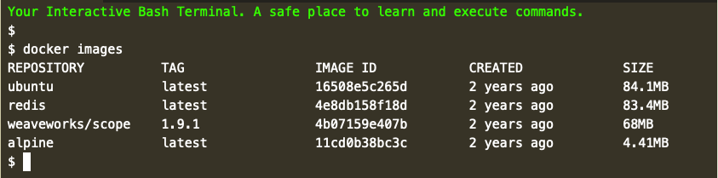

2. docker search redis

Find existing images at [registry.hub.docker.com/](https://registry.hub.docker.com/) or by using the command docker search <name>. For example, to find an image for *Redis.*

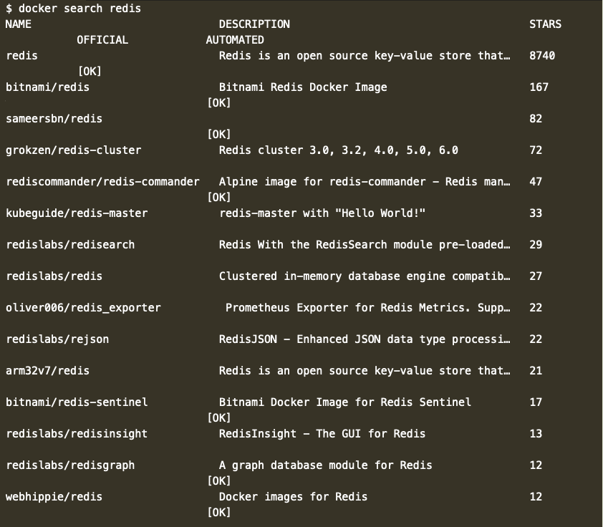

3. docker pull redis

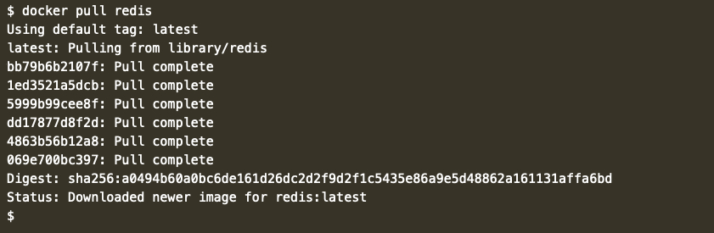

4. docker run -d redis:latest

The Docker CLI has a command called run which will start a container based on a Docker Image. The structure is docker run <options> <image-name>. By default, Docker will run a command in the foreground. To run in the background, the option -d needs to be specified. For example, version 3.2 would be *docker run -d redis:3.2*.



5. docker ps

The launched container is running in the background, this command lists all running containers, the image used to start the container and uptime. This command also displays the friendly name and ID that can be used to find out information about individual containers.

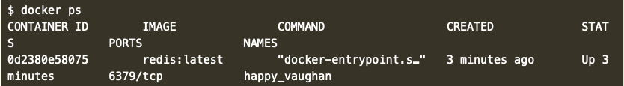

6. docker ps -a

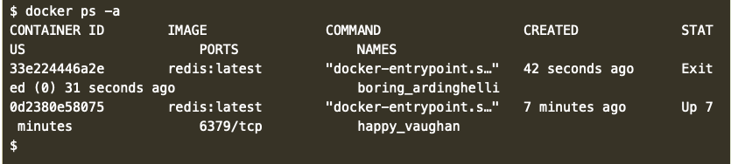

6. docker inspect 0d2380e58075

The command ***docker inspect <friendly-name|container-id>*** provides more details about a running container, such as IP address.

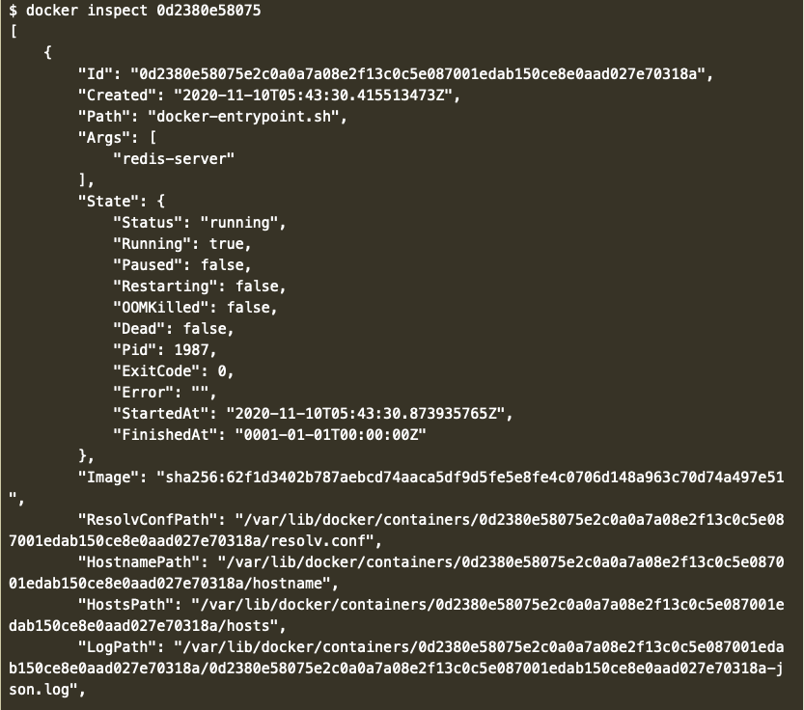

7. docker logs 0d2380e58075

The command ***docker logs <friendly-name|container-id>*** will display messages the container has written to standard error or standard out.

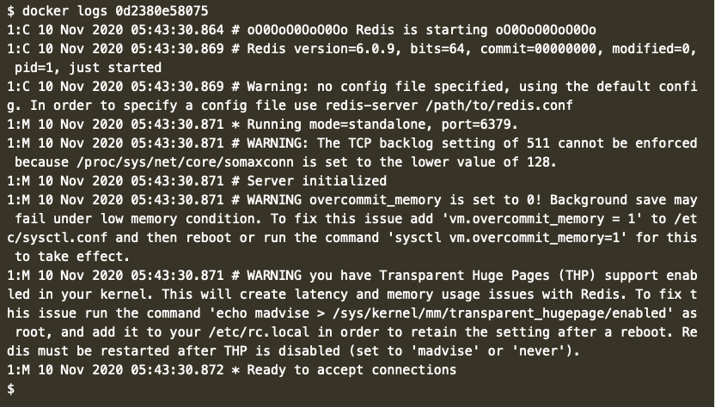

8. docker run -d --name redisHostPort -p 6379:6379 redis:latest

Discovers that ports are bound when containers are started using -p <host-port>:<container-port> option. It also discovers that it's useful to define a name when starting the container, this means that we do not have to use Bash piping or keep looking up the name when trying to access the logs.

Finds the best way to solve her problem of running Redis in the background, with a name of redisHostPort on port 6379 is using the following command.



9. docker run -d --name redisDynamic -p 6379 redis:latest

After experimenting, discovers that just using the option -p 6379 enables to expose Redis but on a randomly available port.



Now doesn't know which port has been assigned. Thankfully, this is discovered ***docker port redisDynamic 6379***



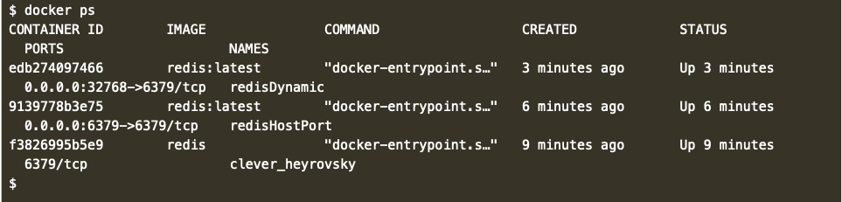

10. docker run -d --name redisMapped -v /opt/docker/data/redis:/data redis

The official Redis image stores logs and data into a /data directory. Any data which needs to be saved on the Docker Host, and not inside containers, should be stored in /opt/docker/data/redis.

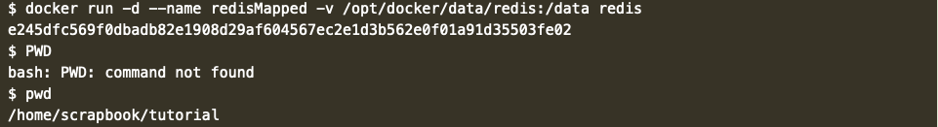

11. docker run ubuntu ps

This command launches an Ubuntu container and executes the command ps to view all the processes running in a container.



12. docker run -it ubuntu bash

This command allows Jane to get access to a bash shell inside of a container.

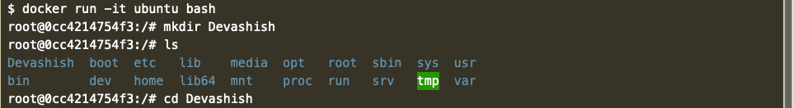

13. docker stop <Container ID> / docker start <Container ID>

These two command is used to start and stop the docker containers.

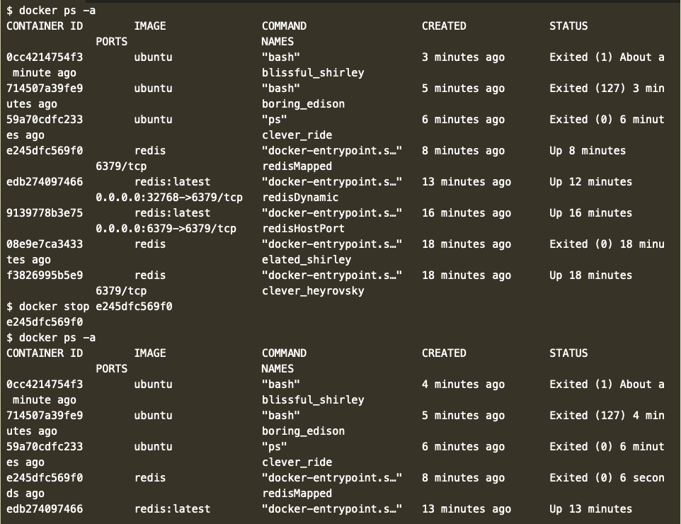

14. docker attach <Container ID>

